ITM 311
FALL SEMESTER 2021
PROFESSOR KATHERINE PAPADEMAS
STUDENT MILAN DEBNATH
DECEMBER 4th, 2021

THE REAL ESTATE SALES CRM SYSTEM

TABLE OF CONTENTS

Page No.

Client Information and Scope of Application………………………………………… 2
Introductory Background on the Application Technology………….…………. 3
GUI Representation ……………………………………………………………………………. 5
MS Visio Chart for UML-Class Diagram ……………………………………………….. 9
Task Objects Events Chart …………………………………………………………………… 9
Flow Chart …………………………………………………………………………………………. 10
Excel Spreadsheet ……………………………………………………………………………… 11
Complete Java Code …………………………………………………………………………… 12
Representation of Output ………………………………………………………………….. 26
References …………………………………………………………………………………………. 33
Appendix …………………………………………………………………………………………… 33

CLIENT INFORMATION

Client Contact Name: Luke K. Jameson, President
Client Company: Newport Real Estate Corporation
Company Address
3300 So. Federal
Chicago, IL 60616
Company Telephone number: 312-BUY-LAND

SCOPE OF PROJECT
Program to create a system that keeps track of available real estate property for sale (inventory), provides actual sales per month, access to a mortgage calculator, and the ability to fill out a customer survey, all to provide customer support.

PROJECT REQUIREMENTS
The client, Newport Real Estate Corporation, operates a nationwide real estate company. This company is famous for providing opportunities for customers to purchase real estate property! Their listings include mansions located on Newport, Rhode Island, to one bedroom studios in Chicago. Their clientele have been satisified with the company’s services, as evidenced by customer survey results sent in by mail, and the company’s agents’ follow up (offering new leads on property, offering management services, as examples).
The company would therefore, like a small scale CRM (Customer Relationship Management) system that would provide such services as real estate listings, mortgage payment calculation, and customer survey fillable forms.

A typical scenario would involve: (1) logon/sign-in to access the system (as information provided is confidential), (2) entering any required customer information, (3) a mortgage calculator (input from the user: purchase price, down payment, principal amount of loan, interest rate,number of years for the loan, and number of payments), (4) customer survey form to be filled by purchaser or seller after a transaction was successfully performed
The survey should appear as follows

1 How satisfied were you with procuring your mortgage?
- Very Satisfied b. Fairly Satisfied c. Satisfied c. Somewhat Dissatisfied d. Very Dissatisfied
2. Did your loan officer answer all your questions?
a. Yes b. No
3. Were all necessary disclosures delivered to you?
a. Yes b. No
4. How satisfied were you with the purchasing process of your new property?
- Very Satisfied b. Fairly Satisfied c. Satisfied c. Somewhat Dissatisfied d. Very Dissatisfied

5. How likely are to you recommend our company?

- Very likely b. Likely c neither likely nor dislikely d. not likely
6. Comments

The client requires a Graphical User Interface that will accommodate its customers to have 24/7 access to its services.

The client must have this application submitted by 12/04/2021 Saturday by midnight, along with this report (as modified). The client also wants the JAVA file(s) associated with this application and evidence that the application is executable without errors.
Introductory Background on Real Estate CRM Systems
Real Estate Industry is the one of a fastest growing industries in human history. Real Estate considered to be the safest place for investment. From corporate to the individual personalities depends on real estate. Food and Shelter is one of the primitive essentials of the human beings. Recession seldom touches this industry.
In modern days, real estate industry has grown up like other industries. Information Technology has boomed this industry. The customers or the clients are now mostly dependent on internet. Thus, the information needs to be accurate and precise. The real estate business is mainly of two types -- Residential and commercial. Residential property had been around nearly from 50000 years ago when human decided to live in caves. The caves are the first residential properties of human being. The Commercial properties are newly invented because of economical purpose. Also, the commercial properties are main component of infrastructural development. Countries are growing rapidly and thereby commercial properties have become more important than residential.
As real estates are concrete investment, its decision-making process is also super important. Information plays a vital role in decision making process. Any miss of information directly hits the financial loss to a company or customer. Therefore, technology has taken a chunk of such responsibility on its shoulder. Big tech companies have found huge potential in this industry. They have incorporated new methodologies and techniques to supplement the competitive market. Like Google has incorporated Maps with accurate coordinates which helps to find the property location within a second over the internet. It accelerates the property valuation process tremendously. Different social media platforms provide listing services. Various mobile apps and websites provide EMI calculators. Beside those, new techniques such as predictive analysis, Artificial Intelligence, Big Data Analysis are also emerging in this field to support decision making process for the customers and the companies.
Overall, many techniques and tools are available in this regard. But the most important tool is CRM or Customer Relationship Management System. CRM is a super captive solution for support, decision, and operation. CRM is useful in all aspects of a business transaction. It keeps record to the potential customer’s profile behavior like buying pattern, spending habit, ARPU, usage of services, etc. But, not only this, CRM provides insight of those data in a form of intelligent format. CRM can generate report at the same time can hold conference collaboration. CRM can perform queries to make your life easy. Many tech companies have developed CRMs, but the most powerful and popular is the Oracle Corporation CRM. It is hardcoded with GUI applications. Oracle CRM is based on java platform. The GUI and the logics are all written in java. It is one of the most powerful CRMs in the world.

MS Visio Chart – GUI Representation for Application

Log In Page
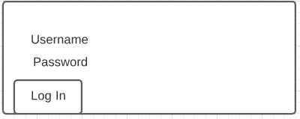

Main Page
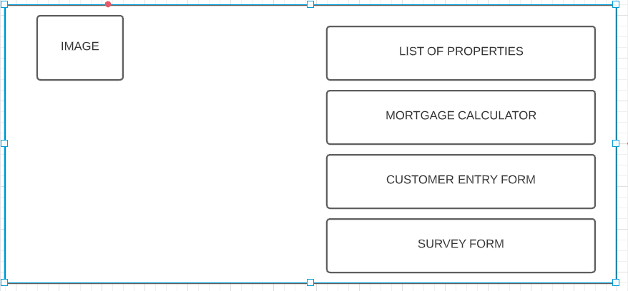

List Of Properties Page
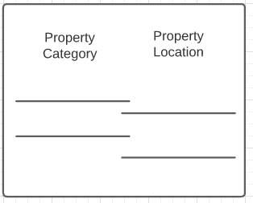

Mortgage Calculator
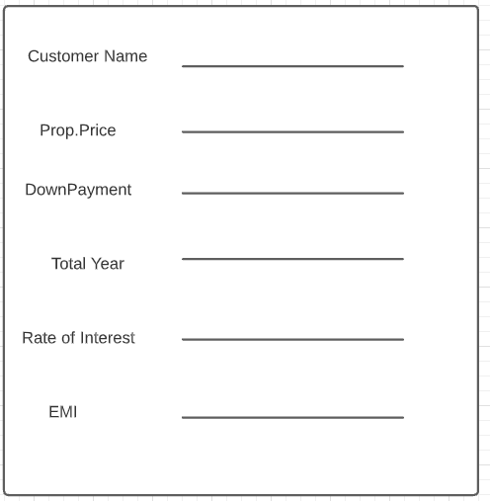

Customer Entry Form
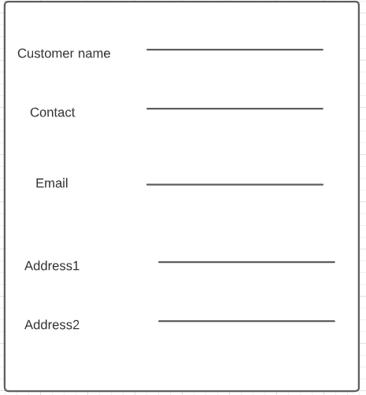

Customer Feedback Form F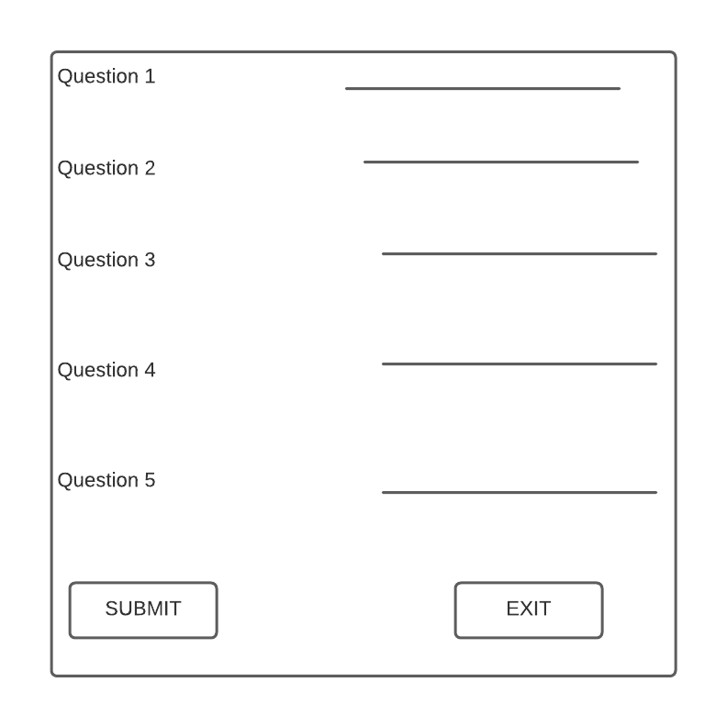

UML Diagram
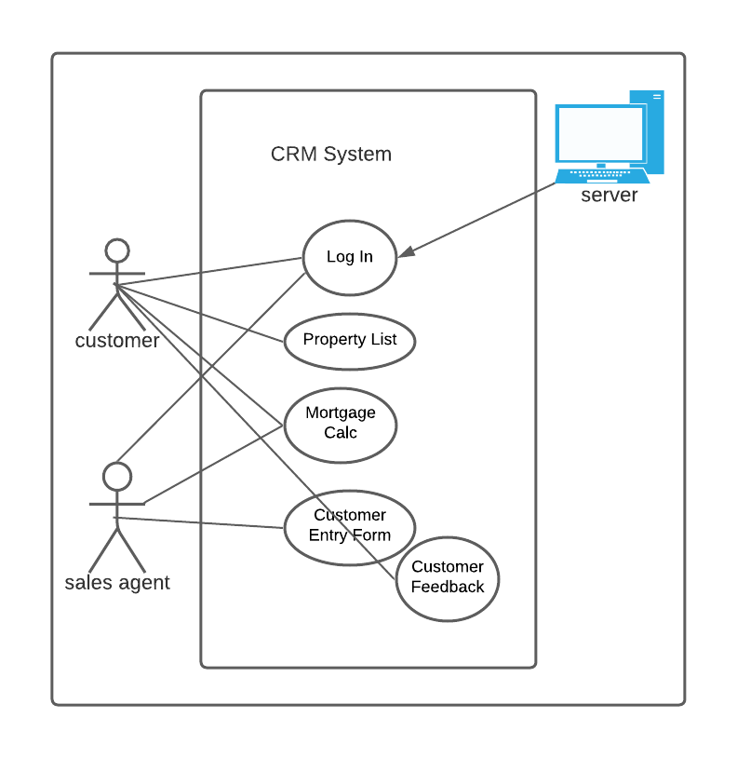
Object | Task | Event
Button Log In | Click | Log in to System.
Menu Item About, contact, project | Click | Show details about
Button calculate, custInfo, Survey | Click | Open New Window
Button submit, ext,exsit | Click | Entering data, Exit from application.
JRadioButton m1-m18 | Select RadioButton | Selecting data and turning value to text;

Flowchart
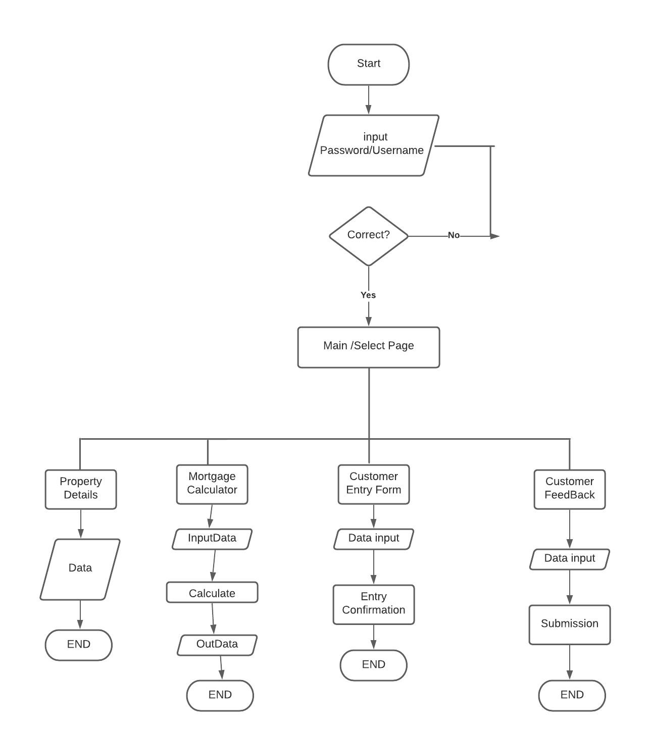

Data on Excel Spreadsheet – for The CRM (Real Estate) System
 | Location of | Property |  |  |  |  | No. years for
Client | Property | Category | Purchase Price | Down Payment | Loan Amount | Interest Rate | mortgage
Mr. & Mrs. Smith | 134 Elm St | Single Family Home | 500000 | 20% | 80% | 0.02 | 30
 | Chicago, IL |  |  |  |  |  | 20
 |  |  |  |  |  |  | 15
Robert Jones | 1600 W. Oak | Condominium | 275000 | 10% | 90% | 0.025 | 15
 | Evanston, IL
Starshine Inc. | 222 Vernor HWY | Warehouse | 4,000,000 | 5% | 95% | 0.03 | 20
 | Detroit, MI

Complete Java Code (with appropriate comment statements)
Log In Page Code
import javax.swing.*;

import java.awt.event.ActionEvent;
import java.awt.event.ActionListener;
import java.awt.*;
import javax.imageio.*;

public class CustCRM extends JFrame implements ActionListener {

private static final long serialVersionUID = 1L;
JButton LogIn;

public void Login () {

this.setSize(400,250);
this.setTitle("Log In");
this.setDefaultCloseOperation(JFrame.EXIT_ON_CLOSE);
this.setLocationRelativeTo(null);
JPanel log = new JPanel();
JLabel username = new JLabel("Username");
JLabel password = new JLabel("Password");
JTextField nameText = new JTextField(20);
JTextField passText = new JTextField(20);
LogIn = new JButton("Log In");
JLabel successMsg = new JLabel("");

add(log);
log.setLayout(null);
username.setBounds(10,20,80,25);
log.add(username);
password.setBounds(10,80,80,25);
log.add(password);
nameText.setBounds(100,20,165,25);
log.add(nameText);
passText.setBounds(100,80,165,25);
log.add(passText);
LogIn.setBounds(10,150,80,25);
log.add(LogIn);
LogIn.addActionListener(this);
successMsg.setBounds(10,110,300,25);
log.add(successMsg);
setVisible(true);

}
@Override
public void actionPerformed (ActionEvent e) {
if (e.getSource()== LogIn) { JOptionPane.showInternalMessageDialog(null, "Log in Success!");
NewWindow mainpage = new NewWindow();
mainpage.Main();
}
}

public class Tester {

public static void main(String[] args) {
try {
CustCRM f = new CustCRM();
f.Login();
}
catch (Exception e) {

JOptionPane.showInternalMessageDialog(null, "Error!" + e.getMessage());
}
}

}
}

Main Page Code
import javax.swing.*;

import java.awt.event.ActionEvent;
import java.awt.event.ActionListener;
import java.awt.*;
import javax.imageio.*;

public class NewWindow extends CustCRM implements ActionListener {
private static final long serialVersionUID = 1L;
JMenuBar menu;
JMenu fileMenu; JMenu projMenu; JMenu AboutMenu;
JMenu ContMenu;JMenu helpMenu; JMenu CarrMenu; JMenu DevMenu;
JMenuItem proj1,proj2,proj3,currop,abt,contt,dev,open,close,exit;
JPanel leftside,Rightside;
JLabel leftlabel,rightlabel1,rightlabel2,rightlabel3,rightlabel4;
JButton prop,survey,calculate,custinfo;
Font f;

public void Main() {
this.setSize(1000,700);
this.setTitle("CRM - Real Estate");
this.setDefaultCloseOperation(JFrame.EXIT_ON_CLOSE);
this.setLocationRelativeTo(null);
this.setLayout(new GridLayout(1,2));
f = new Font("Arial",Font.BOLD,25);
leftside = new JPanel();
Rightside = new JPanel();
Rightside.setLayout(null);
leftlabel = new JLabel();
rightlabel1 = new JLabel();

leftlabel.setIcon(new ImageIcon("Picture1.jpg"));
//property button
prop = new JButton(); prop.addActionListener(this);
prop.setText("Click Here to get our property listing");
prop.setFont(f);
prop.setBounds(10,50,450,80);
rightlabel1.add(prop);
//calculate button
calculate = new JButton(); calculate.addActionListener(this);
calculate.setText("Mortgage Calculator");calculate.setFont(f);
calculate.setBounds(10,180,450,80);
rightlabel1.add(calculate);
//customer data entry button
custinfo = new JButton(); custinfo.addActionListener(this);
custinfo.setText("Customer Entry Form");custinfo.setFont(f);
custinfo.setBounds(10,310,450,80);
rightlabel1.add(custinfo);

//survey button
survey = new JButton(); survey.addActionListener(this);
survey.setText("Customer Survey Form");survey.setFont(f);
survey.setBounds(10,440,450,80);
rightlabel1.add(survey);

///menu bar added
menu = new JMenuBar();
fileMenu = new JMenu("File");
projMenu = new JMenu("Projects");
AboutMenu = new JMenu("About Us");
ContMenu = new JMenu("Contact Us");
DevMenu = new JMenu("Developer");
CarrMenu = new JMenu("Career");
helpMenu = new JMenu("Help");
menu.add(fileMenu); menu.add(projMenu);
menu.add(AboutMenu); menu.add(ContMenu);
menu.add(DevMenu); menu.add(CarrMenu);
menu.add(helpMenu);
open = new JMenuItem("Open");close = new JMenuItem("Close");
exit = new JMenuItem("Exit");
exit.addActionListener(e-> System.exit(0));
fileMenu.add(open); fileMenu.add(close); fileMenu.add(exit);
proj1 = new JMenuItem("Mansions");proj2 = new JMenuItem("House"); proj3 = new JMenuItem("Villas");
projMenu.add(proj1);projMenu.add(proj2);projMenu.add(proj3);
currop = new JMenuItem (" Current Openings"); CarrMenu.add(currop);
abt =new JMenuItem("About"); contt =new JMenuItem("Contacts"); dev =new JMenuItem("Developer");
abt.addActionListener(this);contt.addActionListener(this);
dev.addActionListener(this);
AboutMenu.add(abt);ContMenu.add(contt); DevMenu.add(dev);
this.setJMenuBar(menu);

leftside.add(leftlabel);Rightside.add(prop); Rightside.add(calculate);
Rightside.add(survey); Rightside.add(custinfo);

this.add(leftside); this.add(Rightside);
this.setVisible(true);
}
@Override
public void actionPerformed (ActionEvent e) {
if (e.getSource()== abt) { JOptionPane.showInternalMessageDialog(null, "We are Newport Real Estate Corporation"
+ "We build future homes for the nations\nOur goal is to provide quality housing to all");}
if (e.getSource()== contt) { JOptionPane.showInternalMessageDialog(null, "Newport Real Estate Corporation"
+ "3300 So. Federal\nChicago, IL 60616\nTelephone number: 312-BUY-LAND");}
if (e.getSource()== dev) { JOptionPane.showInternalMessageDialog(null, "Developer Name: Milan Debnath "
+ "IIT Chicago");}
if (e.getSource()== prop) { JOptionPane.showInternalMessageDialog(null, "Property Category\t\t\tProperty Location\t\t\t"
+ "\nSingle Family Home\t\t\t134 Elm St Chicago IL\nCondominium\t\t\t1600 W.Oak Evanston,IL\n"
+ "Warehouse\t\t\t222 Vernor HWY Detroit, MI");}
if (e.getSource() == calculate) {
MortCalc mCalc = new MortCalc();
mCalc.mortCalc();
}
if (e.getSource() == custinfo) {
CustInfo mCust = new CustInfo();
mCust.CustomerInfo();
}
if (e.getSource() == survey) {
CustSurv mCustserv = new CustSurv();
mCustserv.SurvyForm();
}}
}

Mortgage Calculator

import javax.swing.*;

import java.awt.event.ActionEvent;
import java.awt.event.ActionListener;
import java.awt.*;

public class MortCalc extends NewWindow implements ActionListener {

private static final long serialVersionUID = 1L;
JLabel custname,propertyPrice,year,downpay,emi,r,emy;
JButton calculate,ext;
JTextField custnm,yr,downpy,propprice,rate;

public void mortCalc () {
this.setSize(600,700);
this.setTitle("Mortgage Calculaor");
this.setDefaultCloseOperation(JFrame.EXIT_ON_CLOSE);
this.setLocationRelativeTo(null);
this.setLayout(new GridLayout(8,2));
//object initiation
custname = new JLabel("Please enter customer name");
propertyPrice = new JLabel("Please enter property price");
year = new JLabel("Please enter number of years ");
downpay = new JLabel(" Please enter downpayment percentage (%)");
r = new JLabel(" Please enter rate");
emi = new JLabel(" Your monthly EMI");
custnm = new JTextField(10); propprice = new JTextField(10);
yr = new JTextField(10); downpy = new JTextField(10);
emy = new JLabel(); rate = new JTextField(10);
calculate = new JButton(); calculate.setText("Calculate"); calculate.setFont(f);
ext = new JButton(); ext.setText("Exit"); ext.setFont(f);
ext.addActionListener(e->System.exit(0)); calculate.addActionListener(this);
//Add to the Frame
this.add(custname); this.add(custnm);
this.add (propertyPrice); this.add (propprice);
this.add (downpay); this.add (downpy);
this.add (r); this.add(rate);
this.add(year); this.add(yr);
this.add(emi); this.add (emy);
this.add (calculate);this.add(ext);

this.setVisible(true);

}
@Override
public void actionPerformed (ActionEvent e) {
if (e.getSource() == calculate) {

try {

//get values
double purch_price,down_pymt,loan_amt,AnnualIntRate,MonthlyIntRate,monthly_paymnt;
int year,months;
purch_price=Double.parseDouble(propprice.getText());
down_pymt = Double.parseDouble(downpy.getText());
loan_amt = (purch_price / 100) * (100 - down_pymt );
AnnualIntRate = Double.parseDouble( rate.getText() );
MonthlyIntRate = AnnualIntRate / 1200;
year = Integer.parseInt(yr.getText());
months = year * 12;
//Calculate EMI
monthly_paymnt = loan_amt * MonthlyIntRate / (1 - 1 / Math.pow(1 + MonthlyIntRate, months));
//Display output
//String EMI = String.format("%.02f",monthly_paymnt);
emy.setText( String.format("%.02f",monthly_paymnt));
JOptionPane.showInternalMessageDialog(null, "Thank You! " + custnm.getText());
}
catch (Exception E) {
JOptionPane.showInternalMessageDialog(null, "Error!" + E.getMessage());
}
}
}
}

Customer Entry Form Code

import javax.swing.*;

import java.awt.event.ActionEvent;
import java.awt.event.ActionListener;
import java.awt.*;

public class CustInfo extends NewWindow implements ActionListener{
private static final long serialVersionUID = 1L;
JLabel n,c,e,ad1,ad2;
JTextField m,d,f,g1,g2;
JButton sub,exiit;

public void CustomerInfo () {
this.setSize(600,700);
this.setTitle("Customer Entry Form");
this.setDefaultCloseOperation(JFrame.EXIT_ON_CLOSE);
this.setLocationRelativeTo(null);
this.setLayout(new GridLayout(8,2));
//Initiate objects
n = new JLabel("Enter Customer's full name");
c = new JLabel("Enter Customer's contact number");
e = new JLabel("Enter customer's email");
ad1 = new JLabel("Enter customer's current address");
ad2 = new JLabel("Enter customer's permanent address");
m = new JTextField(10);d = new JTextField(10); f = new JTextField(10);
g1 = new JTextField(10); g2 = new JTextField(10);
sub = new JButton(); exiit = new JButton();
//add to the frame
this.add (n); this.add (m); this.add (c); this.add (d);
this.add (e); this.add (f); this.add (ad1); this.add (g1);
this.add (ad2); this.add (g2);
///add button
this.add (sub); this.add (exiit);
sub.setText("Submit"); exiit.setText("Exit");
exiit.addActionListener(e->System.exit(0)); sub.addActionListener(this);

this.setVisible(true);
}

@Override
public void actionPerformed (ActionEvent e) {
if (e.getSource() == sub) {
try {
JOptionPane.showInternalMessageDialog(null, "Records Entered: \nName:\t\t" + m.getText() + "\nContact:\t\t" + d.getText() +
"\nEmail ID:\t\t" + f.getText() + "\nCurrent Address:\t\t" + g1.getText() + "\nPermanent Address:\t\t" + g2.getText() );
}
catch (Exception E) {
JOptionPane.showInternalMessageDialog(null, "Error!" + E.getMessage());
}

}
}
}

Customer Survey Form Code

import javax.swing.*;

import java.awt.event.ActionEvent;
import java.awt.event.ActionListener;
import java.awt.*;

public class CustSurv extends NewWindow implements ActionListener {

private static final long serialVersionUID = 1L;
JLabel m,n,o,p,q,r;
JPanel mm,nn,oo,pp,qq;
JTextField r1;
JRadioButton m1,m2,m3,m4,m5,m6,m7,m8,m9,m10,m11,m12,m13,m14,m15,m16,m17,m18;
ButtonGroup mmm,nnn,ooo,ppp,qqq;
JButton submt,exsit;

public void SurvyForm() {
this.setSize(1000,650);
this.setTitle("Customer Survey Form");
this.setDefaultCloseOperation(JFrame.EXIT_ON_CLOSE);
this.setLocationRelativeTo(null);
this.setLayout(new GridLayout(7,2));
f = new Font("Arial",Font.BOLD,25);

//instantiate objects
m = new JLabel("1.How satisfied were you with procuring your mortgage?");
n = new JLabel("2.Did your loan officer answer all your questions?");
o = new JLabel("3.Were all necessary disclosures delivered to you?");
p = new JLabel("4.How satisfied were you with the purchasing process of your new property?");
q = new JLabel("5.How likely are to you recommend our company?");
r = new JLabel("Comments");
mm = new JPanel();nn = new JPanel();oo = new JPanel();
pp = new JPanel();qq = new JPanel();

//Radio Button initiate
m1 = new JRadioButton("Very Satisfied");m2 = new JRadioButton("Fairly Satisfied");
m3 = new JRadioButton("Satisfied");m4 = new JRadioButton("Somewhat Dissatisfied");
m5 = new JRadioButton("Very Dissatisfied");m6 = new JRadioButton("Yes"); m7 = new JRadioButton("No");
m8 = new JRadioButton("Yes"); m9 = new JRadioButton("No");
m10 = new JRadioButton("Very Satisfied");m11 = new JRadioButton("Fairly Satisfied");
m12 = new JRadioButton("Satisfied");m13 = new JRadioButton("Somewhat Dissatisfied");
m14 = new JRadioButton("Very Dissatisfied"); m15 = new JRadioButton("Very Likely");
m16 = new JRadioButton("Likely"); m17 = new JRadioButton("Neither Likely nor dislikely");
m18 = new JRadioButton("Not Likely");

//Radiobutton to buttonGroup
mmm = new ButtonGroup(); mmm.add(m1); mmm.add(m2);mmm.add(m3); mmm.add(m4); mmm.add(m5);
nnn = new ButtonGroup(); nnn.add(m6); nnn.add (m7);
ooo = new ButtonGroup(); ooo.add(m8); ooo.add(m9);
ppp = new ButtonGroup(); ppp.add(m10); ppp.add(m11); ppp.add(m12); ppp.add(m13);ppp.add(m14);
qqq = new ButtonGroup(); qqq.add(m15); qqq.add(m16); qqq.add(m17); qqq.add(m18);

//add radio to Panel
mm.add(m1); mm.add(m2); mm.add(m3); mm.add(m4); mm.add(m5);
nn.add(m6); nn.add (m7);
oo.add(m8); oo.add (m9);
pp.add(m10); pp.add(m11); pp.add(m12); pp.add(m13); pp.add(m14);
qq.add(m15); qq.add(m16); qq.add(m17); qq.add(m18);

r1 = new JTextField(50);
submt = new JButton();submt.setText("Submit");submt.setFont(f);
exsit = new JButton();exsit.setText("Exit"); exsit.setFont(f);
submt.addActionListener(this); exsit.addActionListener(e->System.exit(0));
//add to the Frame
this.add(m);this.add(mm);this.add(n);this.add(nn);this.add(o);this.add(oo);
this.add(p);this.add(pp);this.add(q);this.add(qq);this.add(r); this.add(r1);
this.add(submt); this.add(exsit);
this.setVisible(true);
}

@Override
public void actionPerformed (ActionEvent e) {
if (e.getSource() ==submt) {

JOptionPane.showInternalMessageDialog(null, "Thank You for providing your valuable feedback!");
System.exit(0);
}
}
}

Snapshots for Output

SNAPSHOTS ARE REQUIRED FOR ALL USER INPUTS! [Example displays…]

Logon

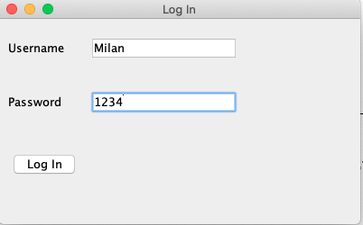

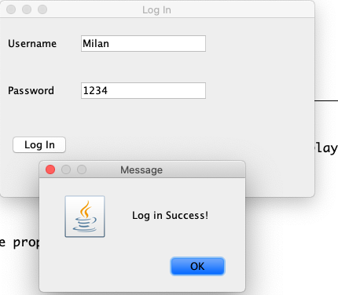

List of Available properties

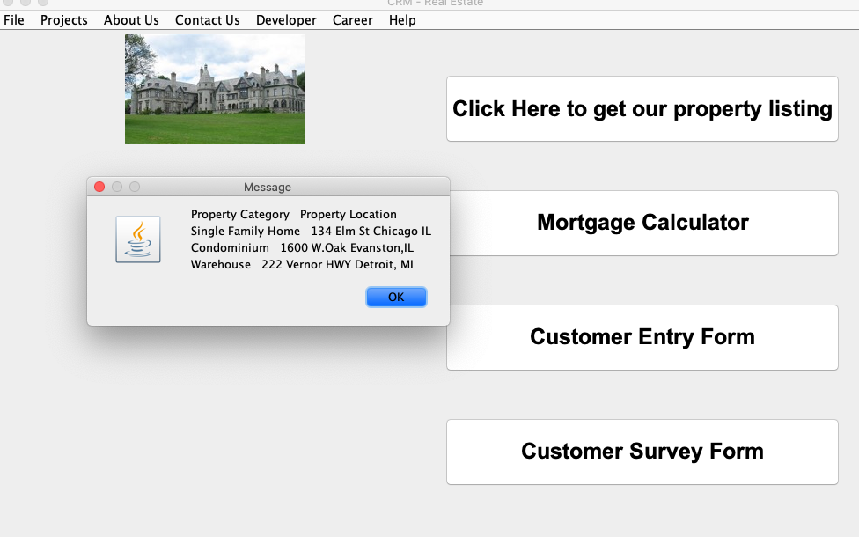

Choice of available property for a buyer
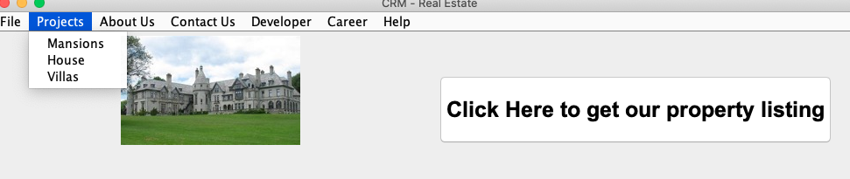

Mortgage Calculator

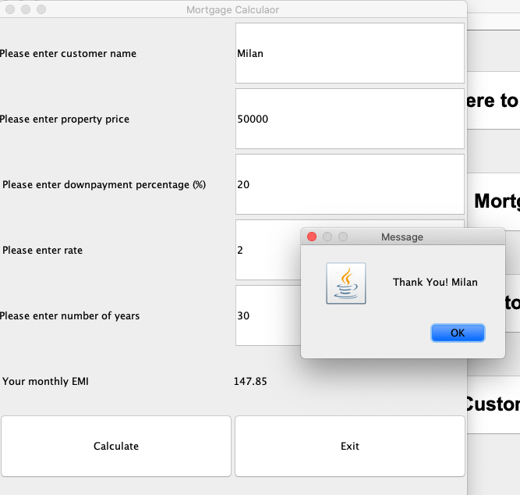
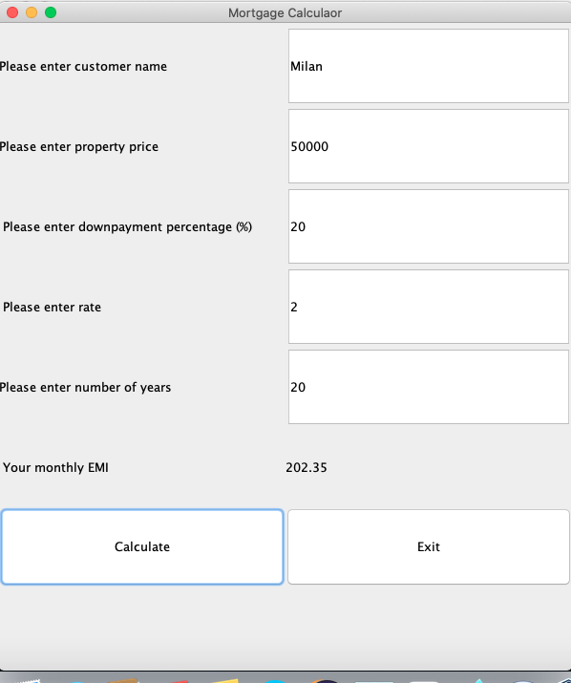

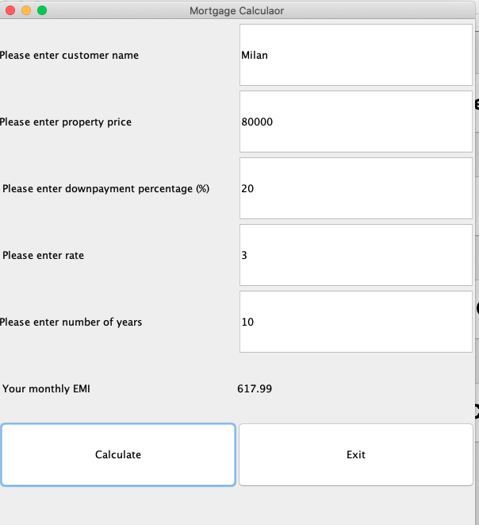

Survey Choices and Results

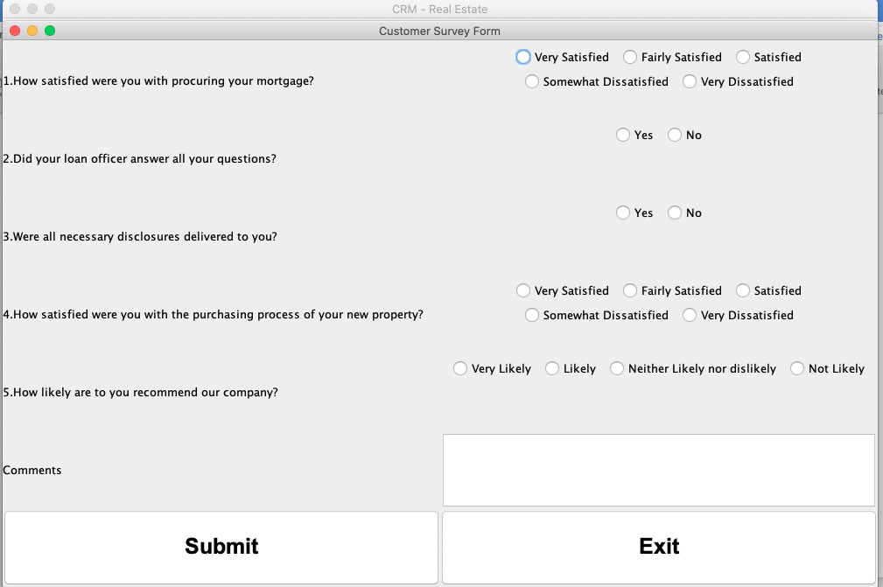
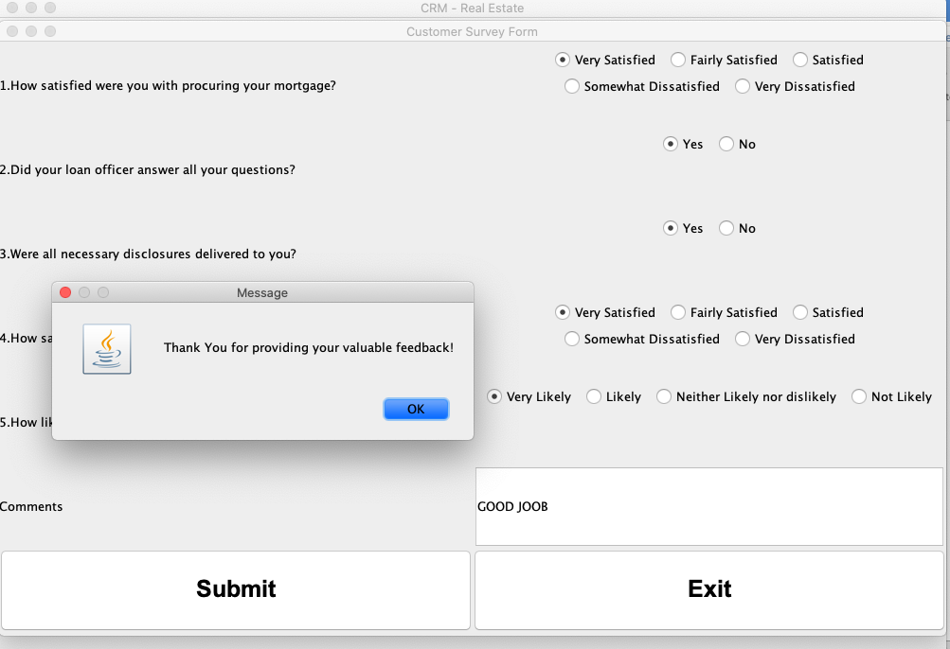

References [APA citation]

Book: Java Programming Joyce Ferrell
stackOverflow- https://stackoverflow.com/questions/5118701/how-to-create-a-gui-in-java
Youtube.com- https://www.youtube.com/watch?v=zid-MVo7M-E
Javapoint- https://www.javatpoint.com/abstract-class-in-java
Code java- https://www.codejava.net/java-se/swing/jpanel-basic-tutorial-and-examples

Appendix


